The problem of web sockets

Dear cyber panel hosting company, I am the NodeJS developer trying to develop the socket.io node project for my client Mukesh who uses this server.

A few days ago we had a problem hosting the node application but now you all have fixed the problem nicely by hosting the application to [**https://socketserver.xyot4.com**](https://socketserver.xyot4.com)

It is perfectly fine and all the dependencies have been installed. The only problem is that web sockets seem to not been enabled by default. The application does not throw any error on my localhost tests and the socket real-time app runs perfectly fine.

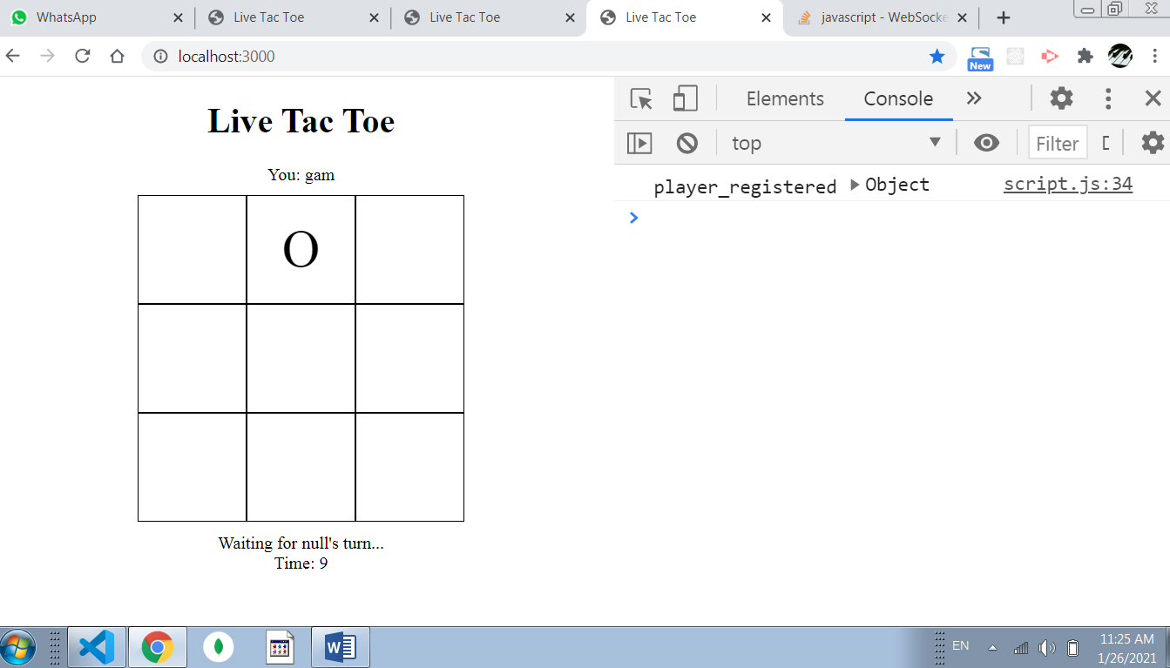

Exactly same hosted project if you try to run in the hosted app you will get to see a bunch of errors thrown to the console saying “Web socket connection was closed before it was established”.

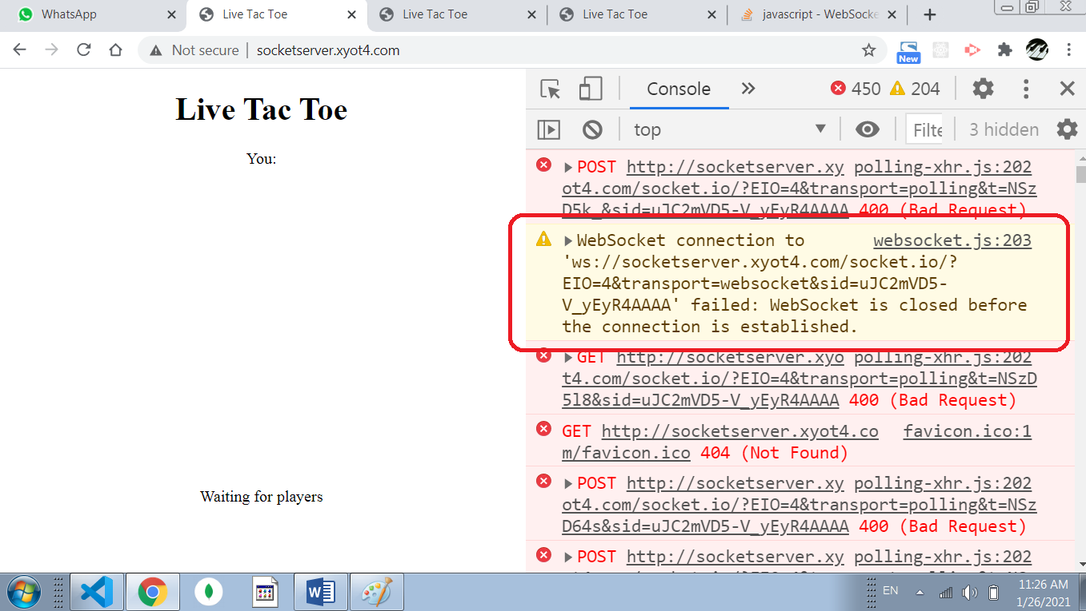

I suppose this is clearly causing because of server configuration is not matching the requirement for real-time web socket communication. Socket.io requires that web socket should be enabled.

Also, the Mukesh client previously stated this issue to you but I got a response that “EJS” was not installed. These are not any concerns as they are so simple and easy and they are not the root cause. We need the solution for the web socket connection.

Everything that is required “socket.io”, “ejs”, “express” etc. is installed before running the app. So, please kindly don’t assume errors from these simple packages and help us to address the root cause.

For your support, I have attached a StackOverflow link here which talks about the apache/Nginx server configuration to upgrade/enable web sockets:

<https://stackoverflow.com/a/60902101/13376958>

Please check out the answer and you may be able to get more ideas from here. We need to get the app done as quickly as possible so please help us to fix this issue of web sockets.

We are waiting for your answer and reply. Thank you so much.